SIEMENS TIA PORTAL LADDER XML ↔ ROCKWELL L5X
Software Design & Implementation Document

1. Purpose
This document records the complete design developed for converting Siemens TIA Portal LAD XML into Rockwell L5X/RLL and for supporting the reverse direction through the same intermediate representation. It combines the architecture, implementation rules, method responsibilities, datatype decisions, topology reconstruction, instruction mapping, literal handling, and validation rules established during development.
The uploaded parser implements a staged flow: interface parsing, CompileUnit/network parsing, Access-tag parsing, timer inference, datatype normalization and instruction datatype inference. The uploaded generator implements AOI construction, parameter/local-tag generation, RLL generation, parallel generation, operand formatting, timer-member conversion and Siemens TIME conversion.

1.1 Goals
- Preserve ladder logic and network order.
- Preserve branch structure and avoid accidental branch nesting.
- Preserve operands, constants, comments and tag information.
- Map supported Siemens instructions to Rockwell instructions.
- Infer datatypes from source declarations and actual instruction usage.
- Generate Rockwell-valid RLL wherever the semantics are supported.
- Report unsupported/ambiguous cases rather than silently inventing logic.

2. Architecture
Siemens LAD XML
↓
SiemensXmlParser
↓
LadderModel / Intermediate Representation
↓
InstructionMapper + DataTypeMapper + semantic normalization
↓
RockwellL5XGenerator
↓
Rockwell L5X / RLL

2.2 Main Components
Component | Responsibility
SiemensXmlParser | Read Siemens XML and reconstruct ladder semantics.
LadderModel | Whole converted program/block.
NetworkModel | One logical ladder network.
LadderNode | Contact, coil, instruction, timer, parallel, etc.
OperandConnection | Pin/value/literal-symbol metadata.
TagModel | Unified tag/interface representation.
InstructionMapper | Bidirectional instruction-name mapping.
DataTypeMapper | Siemens→Rockwell datatype mapping.
RockwellL5XGenerator | Create AOI, tags, parameters and RLL.
SiemensIdGenerator | Generate unique Siemens document IDs.
SiemensUidGenerator | Generate Siemens network UIds.
StringTypes | Maps Siemens String[n] to String_16 / String_32 / STRING (shared by the FB converter and both UDT services).
UdtConversionService | Standalone Siemens UDT XML to Rockwell UDT L5X conversion.
MainStructUdtService | Converts a Struct declared inside an FB into generated Rockwell UDTs.
ConversionReport | Collects declaration changes and per-network changes and writes the conversion report .txt.
HumanInLoopDialog | Pop-up listing networks that need manual verification.

3. Intermediate Data Model
LadderModel
├─ Name
├─ TargetBlockType
├─ Tags : List<TagModel>
└─ Networks : List<NetworkModel>
NetworkModel
├─ Number
├─ Comment
├─ OriginalId
└─ Nodes : List<LadderNode>
LadderNode
├─ Kind
├─ Name
├─ Operand
├─ RawInstruction
├─ Operands : List<OperandConnection>
├─ Children
├─ Branches : List<List<LadderNode>>
├─ OriginalUid
├─ Comment
└─ Negated
OperandConnection
├─ Pin
├─ Value
├─ Kind (Symbol/Literal)
└─ DataType
TagModel
├─ Name
├─ DataType
├─ Description
└─ Usage (Input/Output/InOut/Local)

3.1 LadderNodeKind
Kind | Meaning
Contact | Normally-open/positive contact; Rockwell XIC
NegatedContact | Negated contact; Rockwell XIO
Coil | Normal output coil; OTE
NegatedCoil | Reset-style output; OTU
Instruction | General instruction
Call | JSR/call
Parallel | Explicit parallel branch structure
Or | Siemens O topology marker; not a normal Rockwell instruction
Move | MOV semantics
Timer | Timer instruction
Counter | Counter instruction

4. SiemensXmlParser

4.1 Parse
Main entry point. Validates path/file, loads XML with PreserveWhitespace, validates document IDs, reads block name, parses interface tags, finds CompileUnits, skips CompileUnits without FlgNet, parses networks, reads Access tags, infers timers, normalizes datatypes, infers instruction datatypes and prints diagnostics.

4.2 ValidateDocumentIds
Groups all document-level ID attributes and throws if any ID occurs more than once. Network UIds are local topology identifiers and are not treated as globally unique document IDs.

4.3 ReadBlockName
Finds SW.Blocks.FB/FC/DB and reads AttributeList/Name. Siemens FB Name is an element value, not an FB XML attribute.

4.4 Interface methods
Method | Purpose
ParseInterfaceTags | Read Input, Output, InOut, Static, Temp and Constant sections.
ParseInterfaceSection | Read declarations within one interface section.
ParseInterfaceFallback | Fallback discovery for alternate Siemens layouts.
IsDeclarationElement | Recognize Member, InterfaceMember, Var, Variable and Declaration.
ParseDeclaration | Create/merge TagModel from declaration.
ReadDataType | Extract datatype from attributes/elements/known Siemens types.
NormalizeSiemensDataType | Canonicalize Bool/DInt/Time/timer datatype names.
ReadDeclarationDescription | Extract Description or Comment text.

4.5 Access/tag methods
Method | Purpose
ParseAccessTags | Discover tags from Access elements across the document.
FindAccessDataType | Read Access datatype from attributes/elements.
InferAccessDataType | Fallback inference from symbol/member syntax.
FindAccessDescription | Read Access description.
InferAccessUsage | Determine usage from Access scope; current safe fallback is Local.
AddOrMergeTag | Deduplicate and merge tag declarations.
FindTag | Find tag case-insensitively.
GetRootTagName | Convert Timer.Q/Timer.PRE to root Timer for tag storage.

4.6 Network methods
Method | Purpose
ParseNetwork | Read FlgNet, Parts, Wires, Access map, nodes and topology.
BuildAccessMap | Build UId→AccessInfo map; supports nested/sibling Access.
ParseWire | Separate operands from topology and create WireConnection records.
BuildNetworkTopology | Turn raw wire graph into ordered ladder structure.
BuildPathWithBranches | Walk series logic and detect branch splits.
BuildParallelFromSplit | Start a parallel at an O/split UId.
BuildParallelFromLinks | Build branch lists and resolve their join.
BuildBranchUntilJoin | Traverse one branch until O/shared join.
FindCommonJoin | Find a common downstream branch join.
AddJoinNode | Add a normal join node when it is not topology-only.
MapPart | Map Siemens Part name/negation to LadderNodeKind.

4.7 XML/helper methods
Method | Purpose
ReadComment | Extract network comment.
IsName | Compare XML LocalName independent of namespace URI.
IsCompileUnit | Identify CompileUnit.
IsFlgNet | Identify FlgNet.
ResolveIdentValue | Resolve IdentCon UId through AccessInfo.
IsLiteral | Identify Access literal constant.
IsLiteralSymbol | Identify literal-like values.
IsOperandPin | Identify NameCon pins carrying instruction operands.

5. Wire and Topology Design
ParseWire is deliberately split into two semantic operations. IdentCon + operand NameCon represents an operand association. NameCon-to-NameCon represents ladder topology. This prevents ordinary logic wires from being mistaken for instruction operands.
Wire
├─ NameCon(s)
└─ IdentCon(s)
Operand path:
IdentCon → AccessInfo → OperandConnection
Topology path:
NameCon(source) → NameCon(target)

5.1 Access nesting
Siemens exports can place Access under a Part or as a sibling under Parts. BuildAccessMap therefore uses descendant discovery rather than assuming one exact XML hierarchy.

5.2 Siemens O
O is a topology/distribution construct. It must not be emitted as O(...) in Rockwell. It becomes a Parallel boundary in the intermediate representation.

5.3 Parallel reconstruction
A global visited set used during branch discovery can destroy valid parallel structure. Branch traversal should use a path-local visited set. Explicit O boundaries should have priority over generic common-join detection.
Correct conceptual structure:
XIC(sHomeSol)
[ Branch A: detection conditions,
Branch B: seal-in conditions ]
[ OTE(sErrWorkSenNotLeft),
OTE(qErrWorkSenNotLeft) ]

The second parallel must remain outside the first parallel's branch. A shared branchEndCandidates set should be used for all branches within one parallel reconstruction.

6. Instruction Mapping
Siemens | Rockwell
Contact | XIC
NContact / NegatedContact | XIO
Coil | OTE
NCoil | OTL / preserve set semantics
NegatedCoil | OTU
ONS | ONS
OSR | OSR
OSF | OSF
Move / MOVE | MOV
Equal / Eq / EQ | EQU
NotEqual / Ne / NE | NEQ
GreaterThan / Gt / GT | GRT
GreaterOrEqual / GE | GEQ
LessThan / Lt / LT | LES
LessOrEqual / LE | LEQ
Add | ADD
Subtract | SUB
Multiply | MUL
Divide | DIV
TON | TON
TOF | TOF
RTO | RTO
CTU | CTU
CTD | CTD
RES | RES
JSR | JSR
JMP | JMP
LBL | LBL
MID(IN, L, P) -> OUT | MID(Source,Qty,Start,Dest)
LEN(IN) -> OUT | MOVE(<IN>.LEN,<OUT>)
Chars_TO_Strg(Chars, pChars, Cnt, Strg) | COP(Chars[pChars],Strg.DATA[0],Cnt)
MOVE between UDT / struct operands (UDT-UDT, struct-UDT, UDT-struct) | COP(source,destination,0) (length always 0)
MOVE_BLK | COP
FILL_BLK | FLL
CONV | MOVE
N_TRIG | OSF(Storage,Output)
PBox / P_TRIG | ONS(Storage)
NOT block (operand-less) | No Rockwell instruction. Inverts the preceding comparison; network flagged HUMAN IN LOOP.

Unknown instructions should be reported or preserved as far as possible. Do not silently substitute a different instruction.

7. Datatype Design
Siemens | Rockwell
BOOL | BOOL
SINT | SINT
USINT | SINT
INT | INT
UINT | INT
DINT | DINT
UDINT | DINT
LINT | LINT
ULINT | LINT
BYTE | SINT
WORD | INT
DWORD | DINT
LWORD | LINT
REAL | REAL
LREAL | LREAL
TIME | DINT
TON_TIME | TIMER
TOF_TIME | TIMER
TP_TIME | TIMER
TONR_TIME | TIMER
TIMER | TIMER
COUNTER | COUNTER
STRING / String[n] with n > 32 | STRING
String[1..16] | String_16 (Dimension 0)
String[17..32] | String_32 (Dimension 0)
CHAR | SINT (Radix ASCII inside UDTs)
WCHAR | INT
LTIME | LINT
CTU / CTD / CTUD (for example CTU_INT) | COUNTER

7.1 Datatype inference methods
Method | Rule
InferInstructionDataTypes | Recursively inspect networks, branches and children.
InferMoveDataType | MOV(500,Tag) → DINT; MOV(T#500MS,Tag) → DINT; copy known numeric source type.
InferComparisonDataType | Numeric literal on one side → symbolic operand inferred numeric/DINT.
InferArithmeticDataType | ADD/SUB/MUL/DIV symbolic operands inferred numeric where unknown.
InferTimerTags / InferTimerTagsFromNodes | Infer timer roots from actual timer instructions/members.
InferTimerOperandDataType | Timer root → TIMER; PRE/ACC remain DINT members.
SetTagDataType | Apply evidence without overwriting explicit source datatype incorrectly.
NormalizeTagDataTypes | Finalize canonical source datatypes.

8. Literal and Constant Handling
TRUE, FALSE, numeric constants and T# duration values are literals, not tags. They must not be inserted into the Rockwell Parameters or LocalTags collections.
Value | Tag? | Target treatment
TRUE | No | Kept as written: XIC(TRUE) / XIO(TRUE). The network is flagged HUMAN IN LOOP and listed in the conversion report.
FALSE | No | Kept as written: XIC(FALSE) / XIO(FALSE). The network is flagged HUMAN IN LOOP and listed in the conversion report.
0 / 1 / 500 | No | Keep as numeric literal.
T#500MS | No | Convert to 500 milliseconds.
iResetModule | Yes | Normal symbol/tag.
Timer.Q | Timer only | Convert to Timer.DN only when Timer is TIMER.
Timer.PRE/ACC | Timer only | Keep member name; root remains TIMER.

IsBooleanLiteral can remain for classification/tag-discovery purposes. It should not cause TRUE/FALSE to become tags.

9. RockwellL5XGenerator
Method | Responsibility
Generate | Build complete RSLogix5000Content, Controller, AOI, Parameters, LocalTags, Routine and RLL.
GetUniqueTags | Case-insensitive tag deduplication.
BuildTagTypeMap | Root tag → Rockwell datatype map.
CreateSystemParameter | EnableIn/EnableOut hidden BOOL parameters.
CreateParameter | Input/Output/InOut AOI parameter generation.
CreateLocalTag | LocalTag generation; TIMER gets decorated structure.
CreateDecoratedDefault | Decorated DataValue generation.
GetDefaultL5KValue | Datatype default value.
GetDecoratedValue | Decorated scalar value.
CreateRung | Rung number, comment and Text.
BuildRll | Concatenate nodes and terminate rung with ';'.
BuildNode | Dispatch node to Rockwell instruction text.
BuildParallel | Generate [branch1,branch2] syntax.
GetRockwellOperation | Map node kind to target operation.
GetTimerInstructionName | Normalize TON/TOF/RTO.
GetCounterInstructionName | Normalize CTU/CTD/etc.
GetInstructionName | Map general instruction name.
GetOperandText | Use structured operands, then legacy Operand fallback.
FormatOperand | Format OperandConnection according to Literal/Symbol.
FormatLegacyOperand | Format legacy single operand.
FormatLiteral | Format constants and Siemens TIME values.
FormatSymbol | Format symbols.
ConvertTimerMember | TIMER.Q → TIMER.DN only.
TryConvertSiemensTimeToMilliseconds | Parse composite T# values.
IsSiemensTimeLiteral | Detect T#.
IsQuotedString | Detect quoted strings.
IsBooleanLiteral | Detect TRUE/FALSE.
IsNumericLiteral | Detect numeric constants.
RequiresOperand | Prevent malformed instructions.

9.1 Rockwell tag generation
- Input/Output/InOut become AOI Parameters.
- Local tags become LocalTags.
- TIMER LocalTags contain PRE, ACC, EN, TT and DN members.
- TRUE/FALSE/numeric/T# literals never become tags.
- Duplicate tag names are suppressed case-insensitively.

9.2 Empty networks
A CompileUnit without FlgNet is treated as a header/configuration block and is skipped. A network with no meaningful nodes is not emitted as an empty Rockwell rung.

10. Timer Conversion
Siemens Rockwell
------------------------------------------------
TON_TIME / TOF_TIME / TP_TIME
/ TONR_TIME -> TIMER
TIME duration -> DINT (milliseconds)
Timer.Q -> Timer.DN
Timer.PRE -> Timer.PRE
Timer.ACC -> Timer.ACC
Timer.EN -> Timer.EN
Timer.TT -> Timer.TT
Timer.DN -> Timer.DN

10.1 Time conversion examples
Siemens | Milliseconds
T#1H | 3600000
T#1M | 60000
T#1S | 1000
T#500MS | 500
T#1H30M | 5400000

Do not include TOFF_TIME in the agreed mapping. Use TOF_TIME.

11. Comments and Metadata
- Network comments are stored in NetworkModel.Comment and emitted as Rockwell LocalizedComment/en-US.
- Tag descriptions are preserved where available.
- OriginalId and OriginalUid provide traceability to source XML.
- Block name is read from Siemens AttributeList/Name.

12. Validation Strategy
- Validate input path/file.
- Validate duplicate Siemens document IDs.
- Verify actual FlgNet network count and order.
- Inspect intermediate nodes, branches and operands.
- Generate Rockwell XML and verify it is well formed.
- Import/validate generated L5X in Rockwell.
- Compare reference and generated RLL network-by-network.
- Where reverse parsing is available, perform source→IR→target→IR semantic comparison.

12.1 Semantic comparison fields
- Network count/order.
- Branch count and nesting.
- Instruction names after mapping.
- Operand count, pin and value order.
- Tag names and datatypes.
- Comments/descriptions.
- Timer member semantics.
- Literal vs symbol classification.

13. End-to-End Method Flow
Generate/Parse flow
SiemensXmlParser.Parse
├─ ValidateDocumentIds
├─ ReadBlockName
├─ ParseInterfaceTags
│ ├─ ParseInterfaceSection
│ ├─ ParseInterfaceFallback
│ ├─ ParseDeclaration
│ └─ ReadDataType
├─ ParseNetwork
│ ├─ BuildAccessMap
│ ├─ MapPart
│ ├─ ParseWire
│ └─ BuildNetworkTopology
│ ├─ BuildPathWithBranches
│ ├─ BuildParallelFromSplit
│ ├─ BuildParallelFromLinks
│ └─ BuildBranchUntilJoin
├─ ParseAccessTags
├─ InferTimerTags
├─ NormalizeTagDataTypes
└─ InferInstructionDataTypes
├─ InferMoveDataType
├─ InferComparisonDataType
├─ InferArithmeticDataType
└─ InferTimerOperandDataType
RockwellL5XGenerator.Generate
├─ BuildTagTypeMap
├─ CreateSystemParameter
├─ CreateParameter
├─ CreateLocalTag
├─ CreateRung
│ └─ BuildRll
│ └─ BuildNode
│ ├─ BuildParallel
│ ├─ GetRockwellOperation
│ └─ GetOperandText
│ ├─ FormatOperand
│ ├─ FormatLegacyOperand
│ ├─ FormatLiteral
│ └─ FormatSymbol
│ └─ ConvertTimerMember
└─ Save XDocument

14. Reverse Conversion Architecture
Rockwell L5X
↓
Rockwell Parser
↓
LadderModel
↓
Siemens XML Generator
↓
Siemens TIA LAD XML

The same intermediate model should be reused. Reverse conversion must remain semantic: for example, Rockwell DINT should not automatically become Siemens TIME without evidence that the value represents a duration.

15. New Methods and Class Added

1. RockwellTagValidator Class
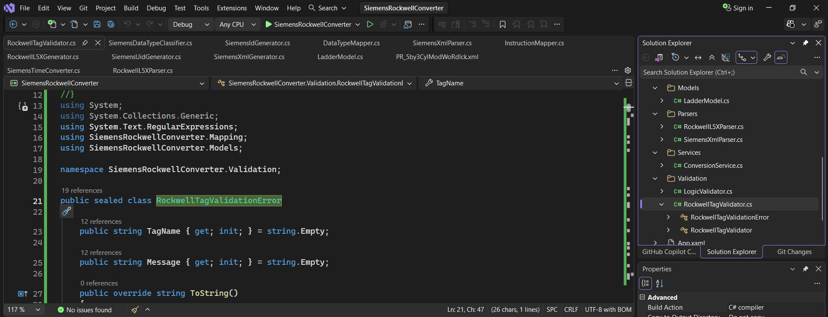

- RockwellTagValidator.cs
  - Checks whether Rockwell tags/parameters have valid names, datatypes, UDTs, arrays, and usage.
  - Detects invalid Rockwell definitions before conversion.
  - Helps prevent generating invalid L5X/Siemens XML.
- RockwellTagValidationError.cs
  - Represents one validation error found by the validator.
  - Stores:
    - TagName → which tag/parameter has the problem
    - Message → what is wrong
  - Allows the application to collect and display multiple validation errors clearly.
2.DataTypeMapper Class
- DataTypeMapper.cs – Converts and maps Siemens data types to Rockwell data types and vice versa, ensuring compatible datatypes are used during conversion.
- Example: DInt → DINT, Real → REAL, Bool → BOOL, Time → DINT, etc.

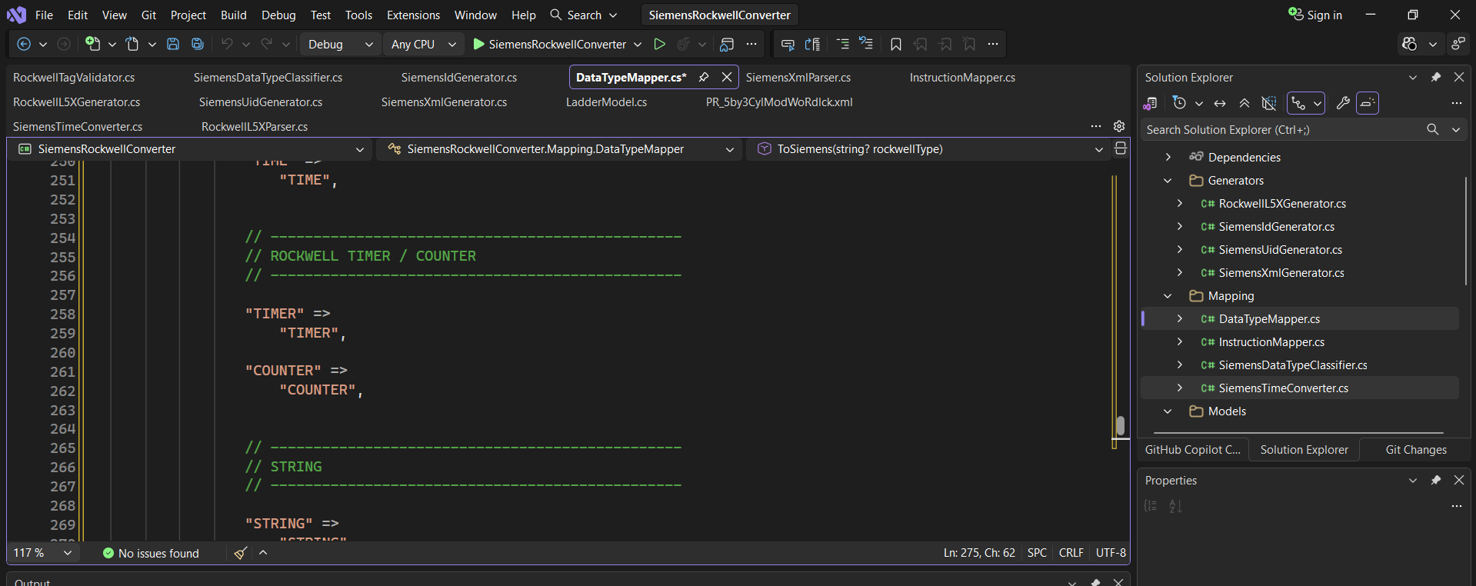
3. Changes Done in DatatypeMapper.cs , SiemensDataTypeClassifier.cs for UDT Conversion.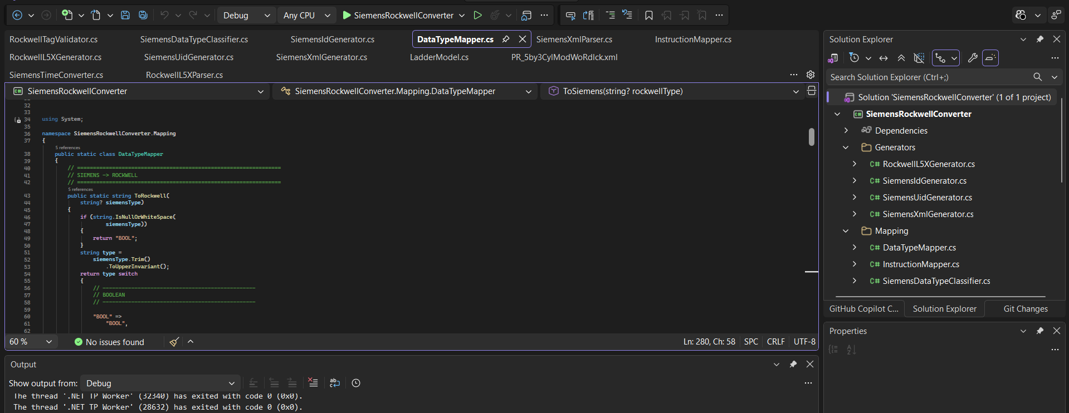
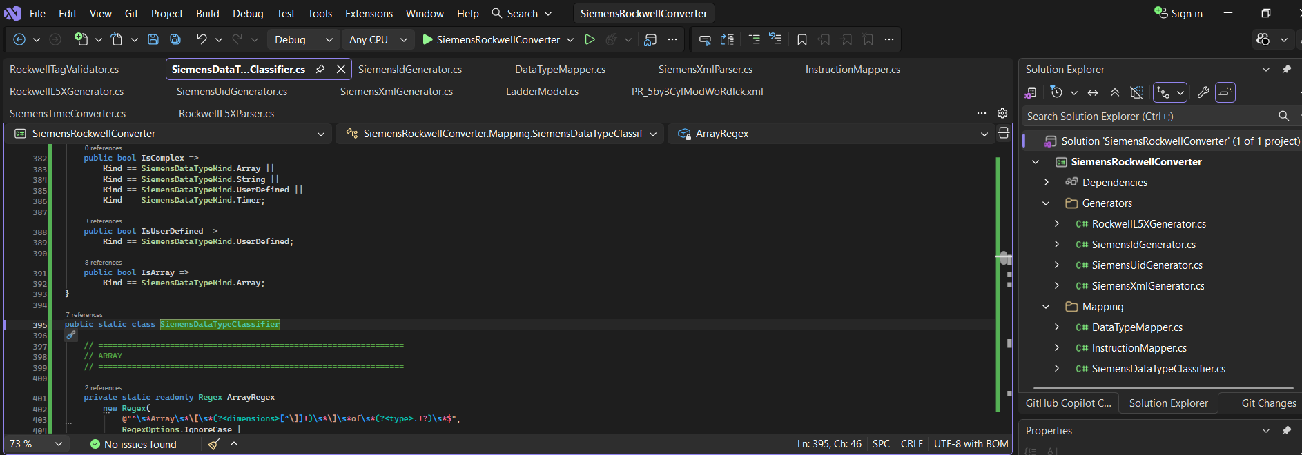
- Added New Methods and files for Siemens To Rockwell Datatype Conversion DataTypeConversionService() , DataTypeConverterWindow.xaml , DataTypeConverterWindow.xaml.cs
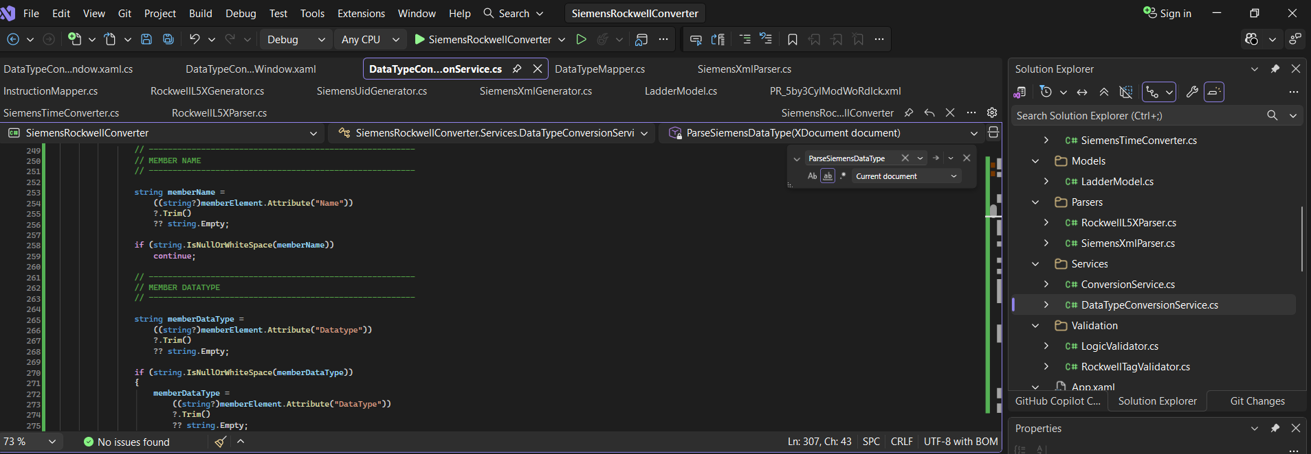

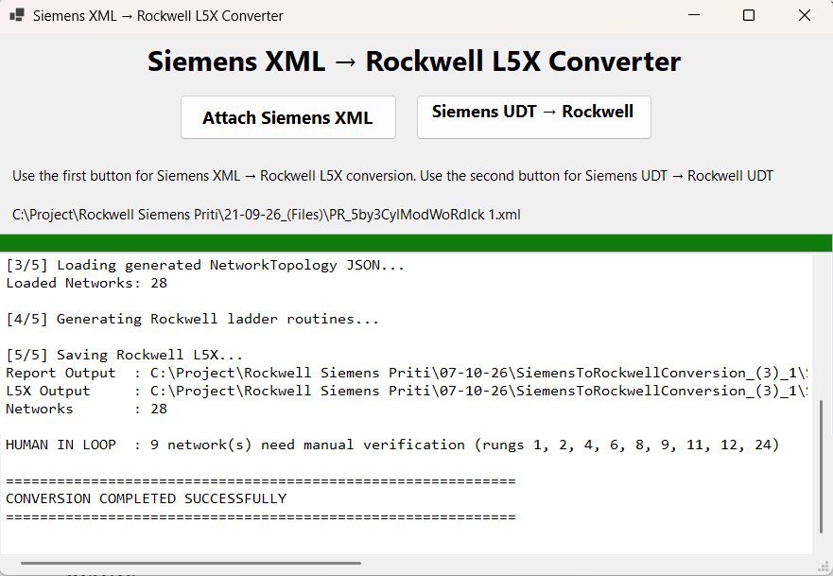
- Added Methods to Convert Rockwell To Siemens User Defined Datatype Conversion.
Methods added RockwellToSiemens()
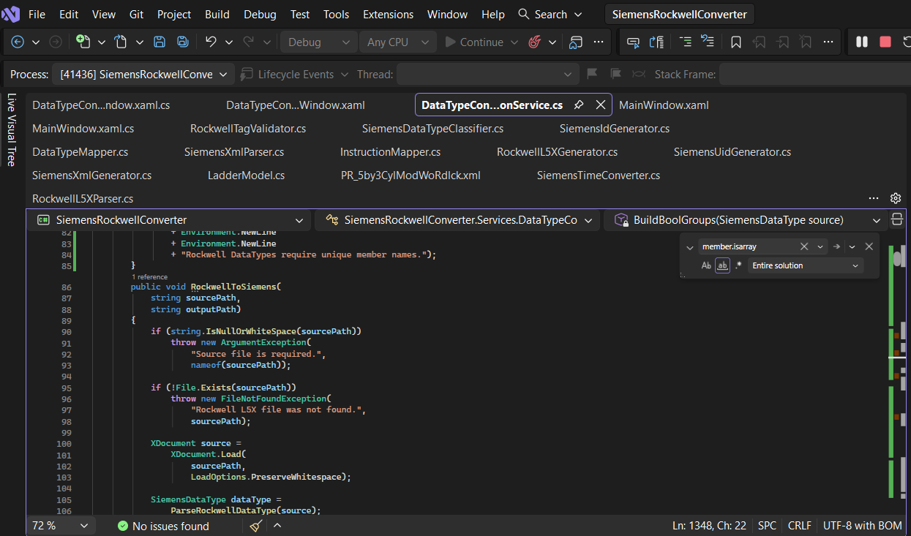

- Added Method BuildRockwellMembers() , TryParseSiemensArrayType() For Array Datatype conversion 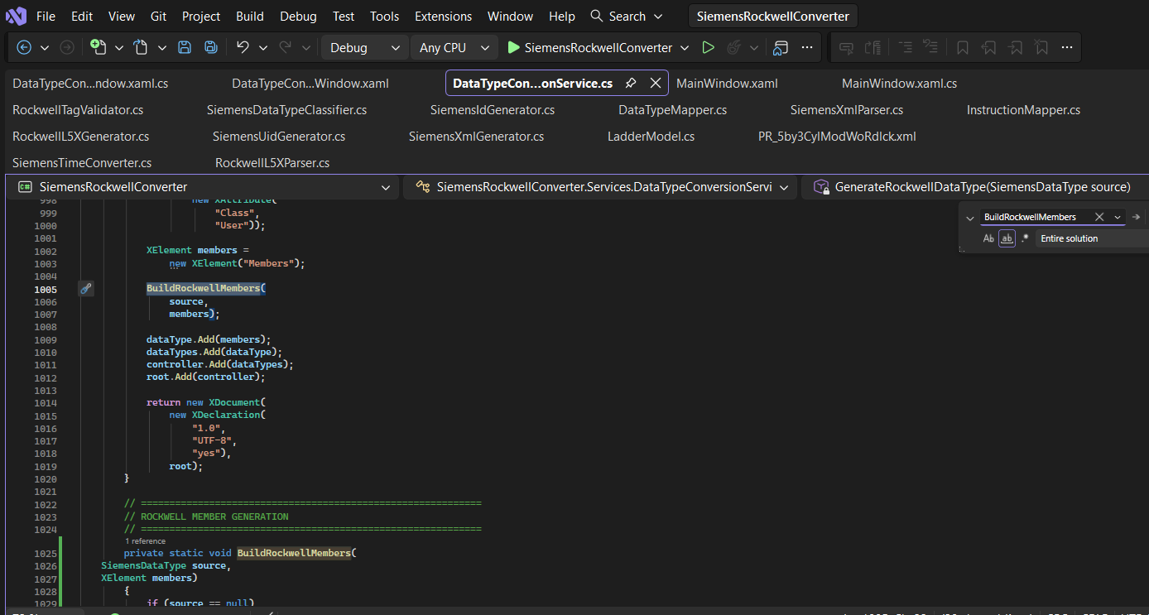
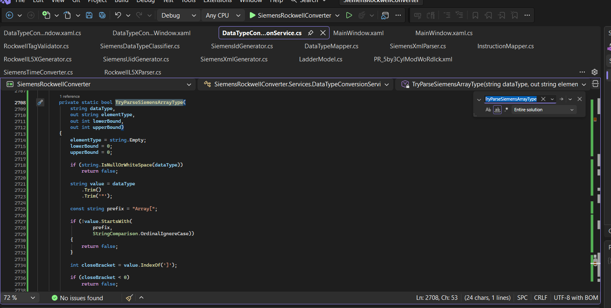
Result :
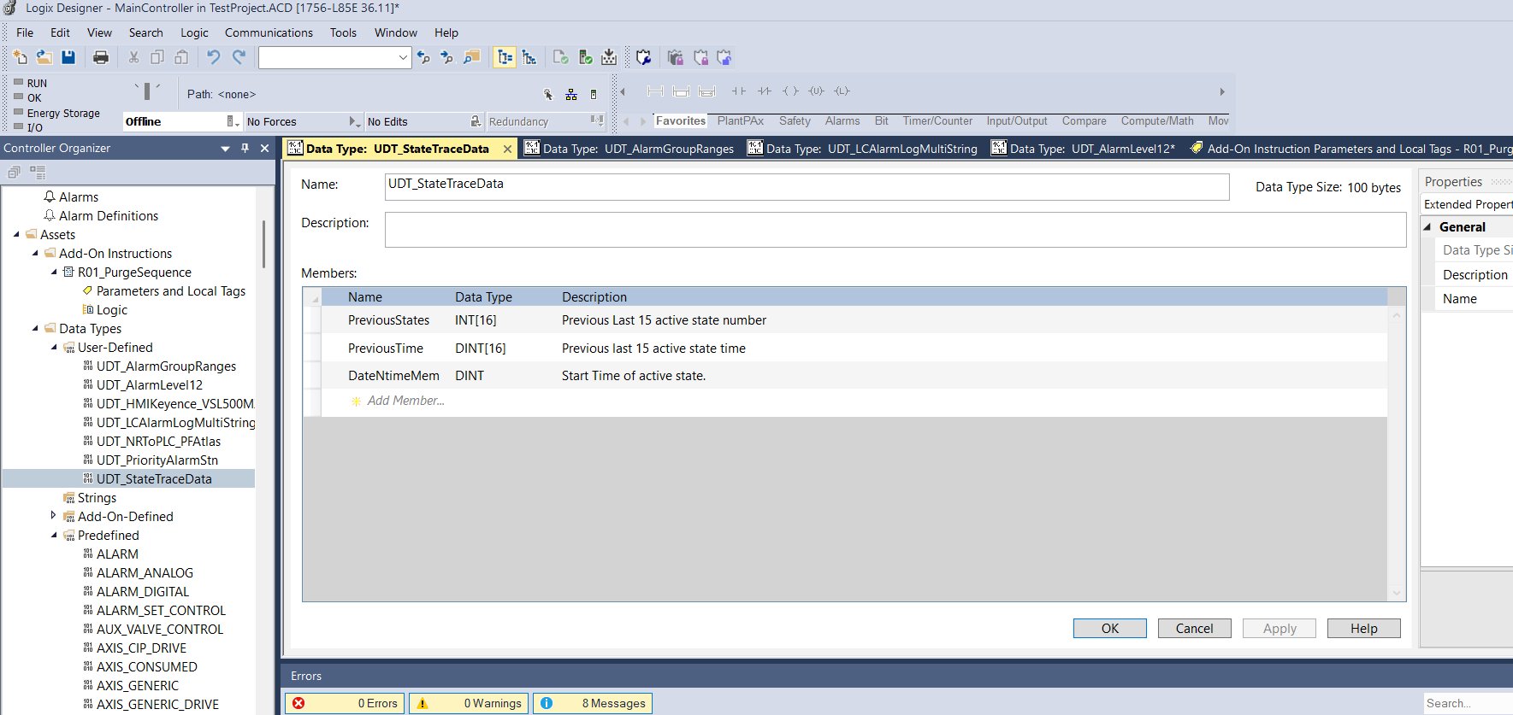
- TryBuildSiemensOrBackwardNested() , BuildParallelFormlinks() and BuildBranchUntilJoin() Methods changed for coil correction but still not added correctly.
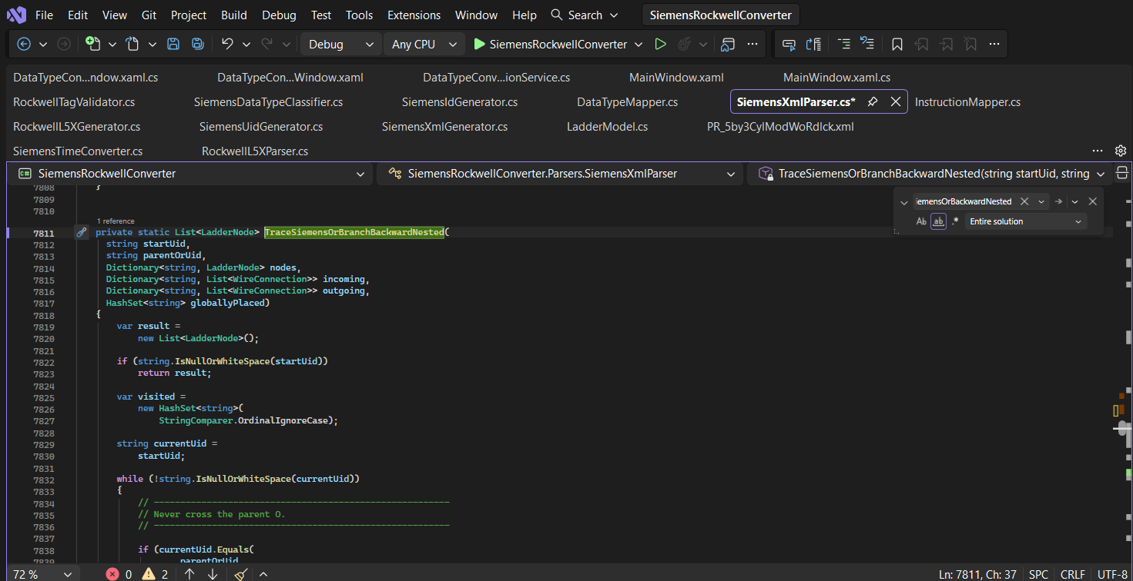

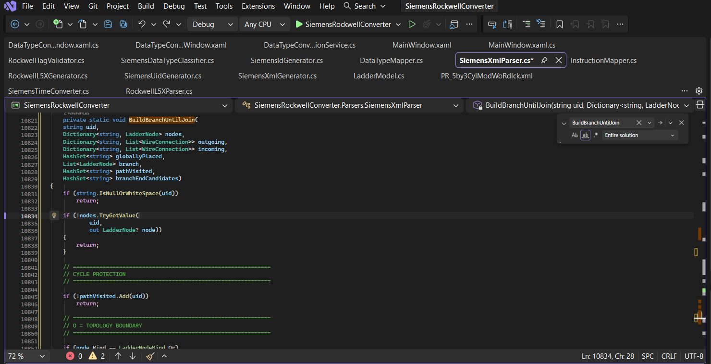
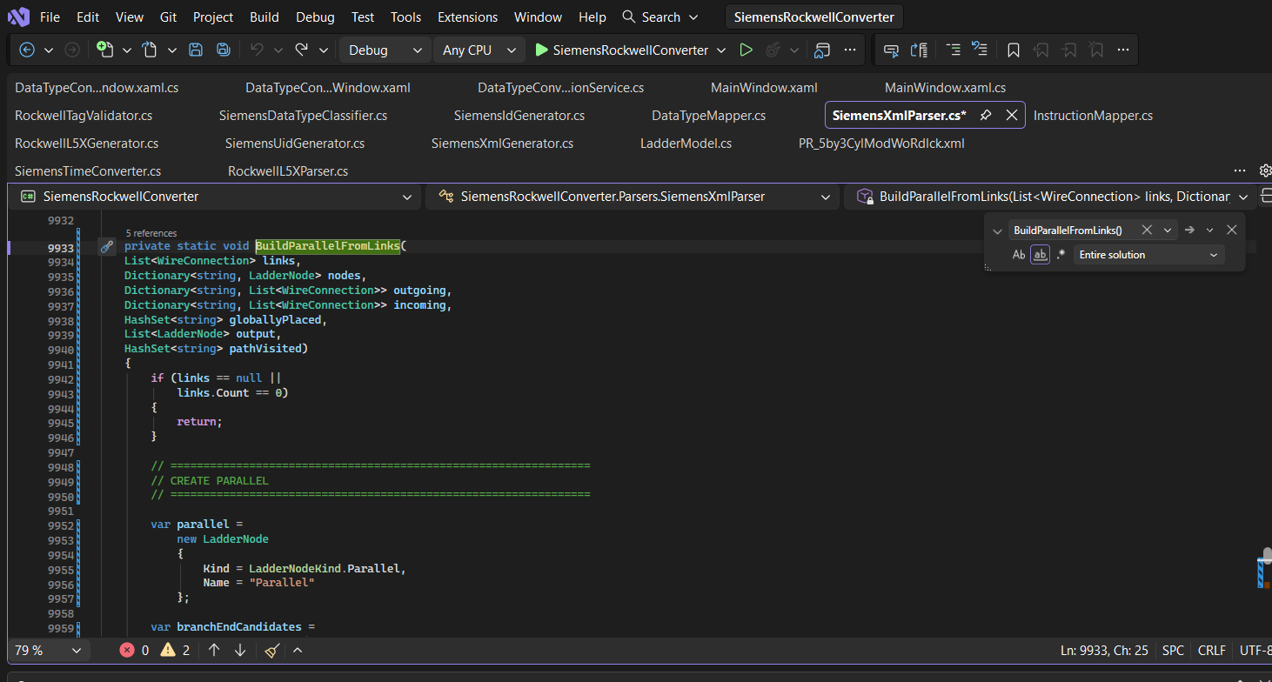
- CreateParameter() method changed for following error.
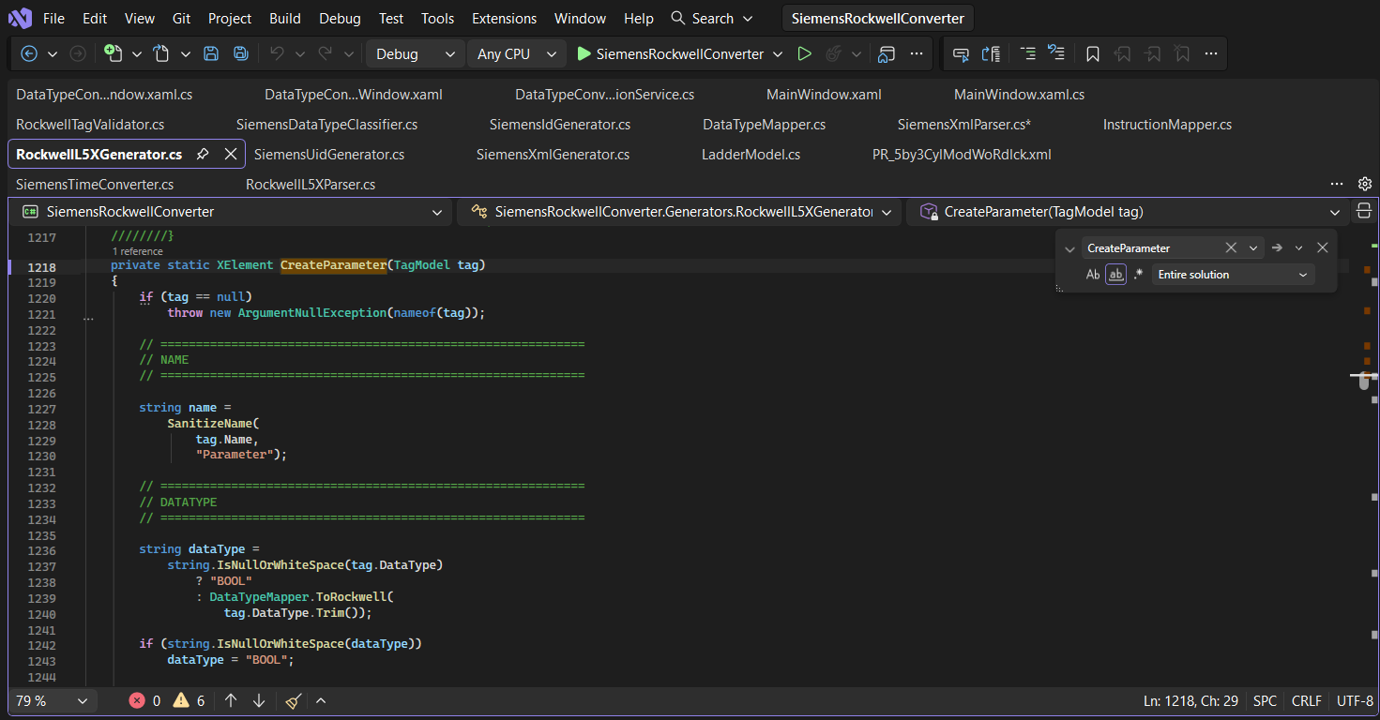
Error:
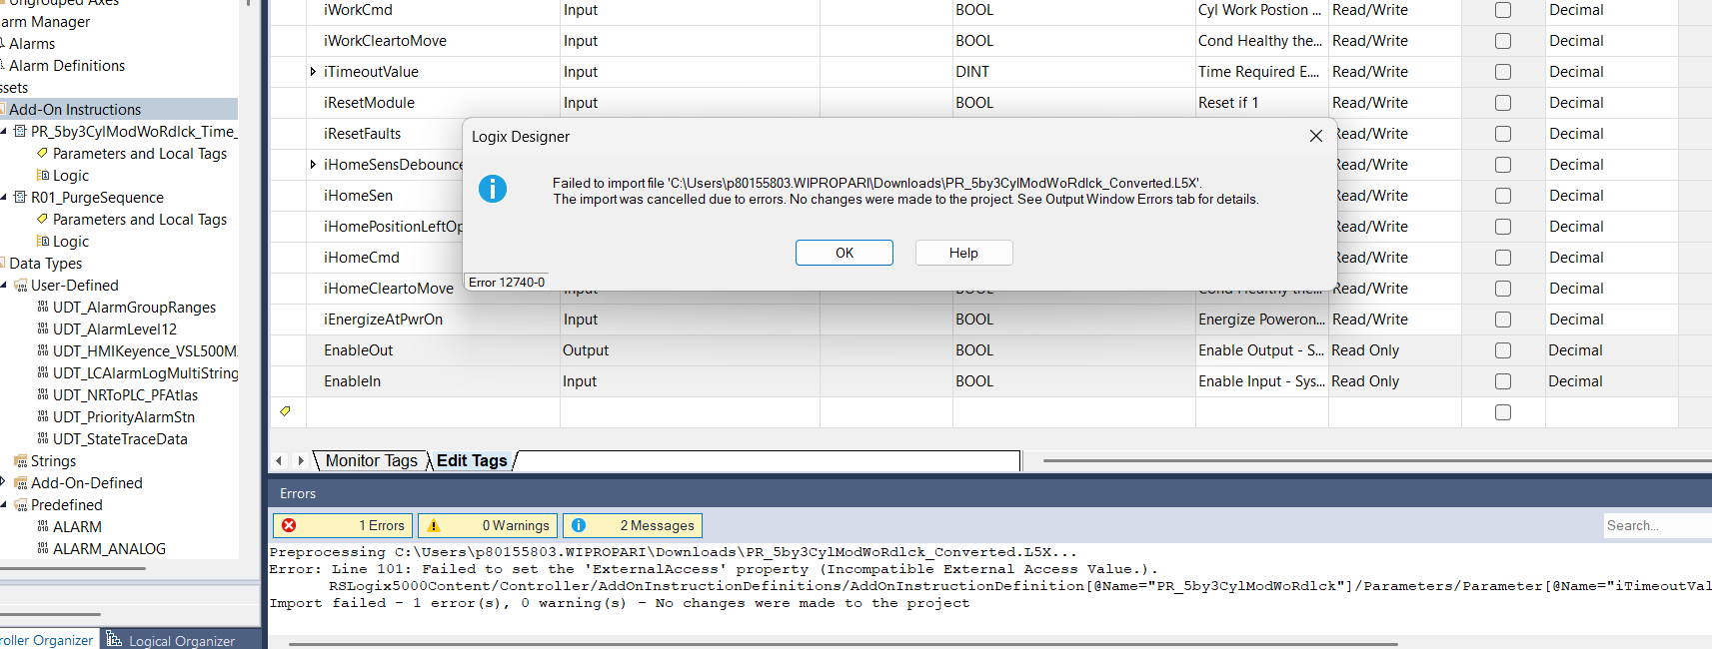
- FindCommonBranchBoundary(), TraceNestedBranchBackward(),BuildNestedSiemensOrNode(), TryBuildSiemensOrBackwardNested() Methods changed for Nested branches.
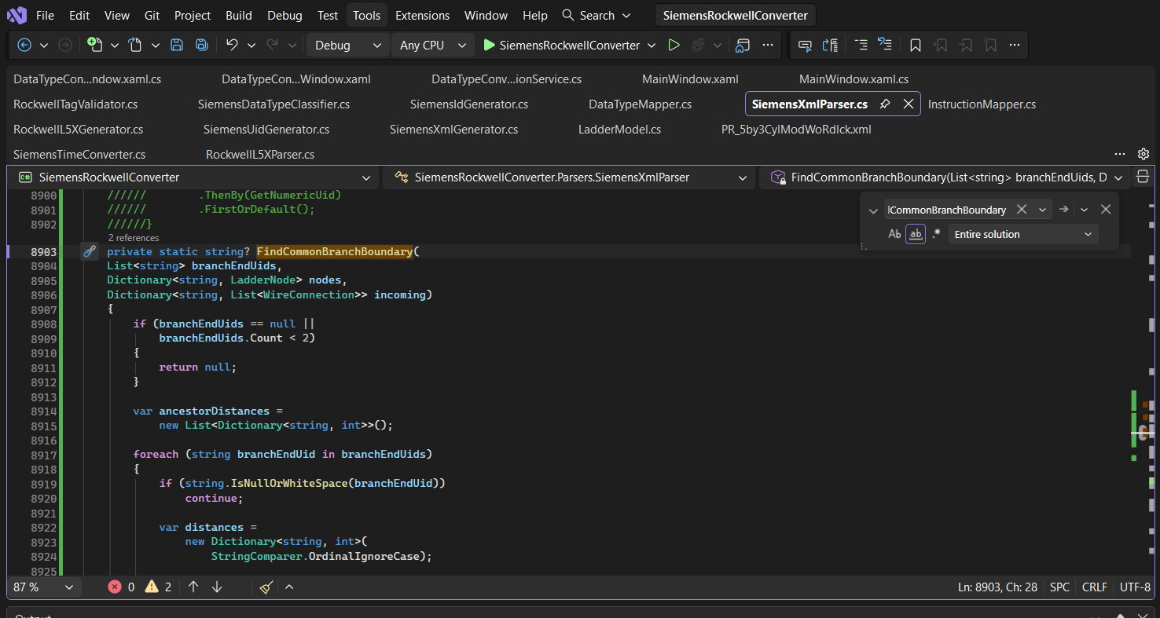

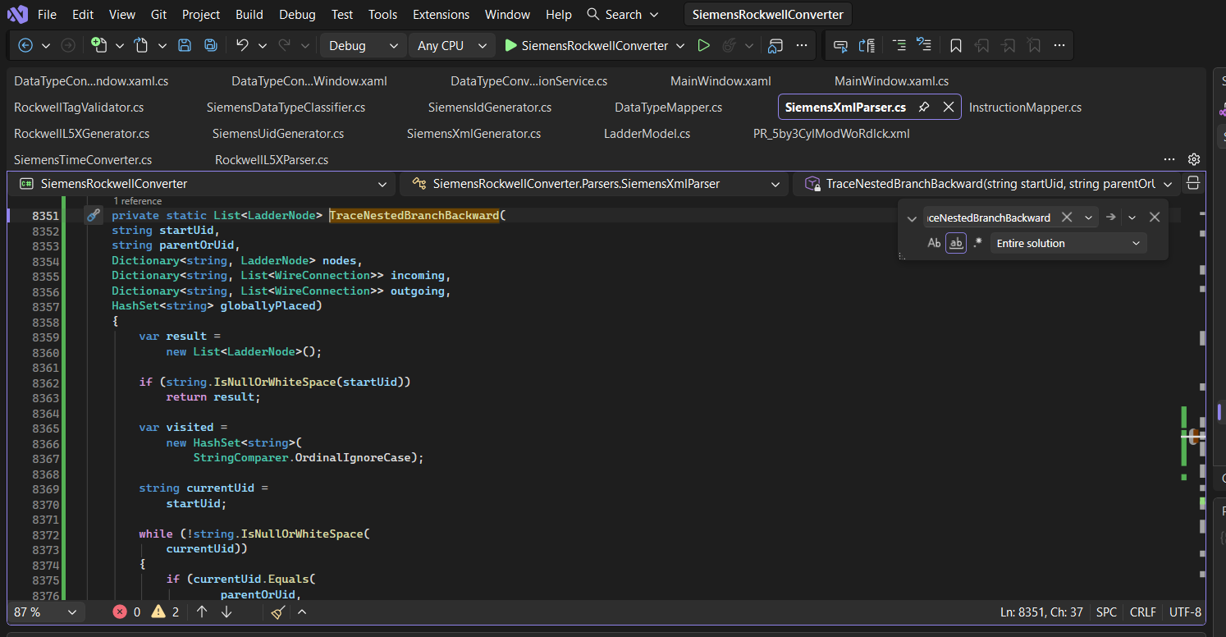
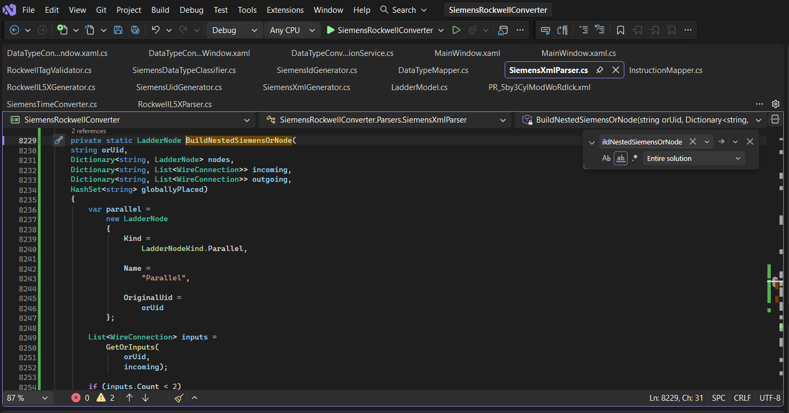
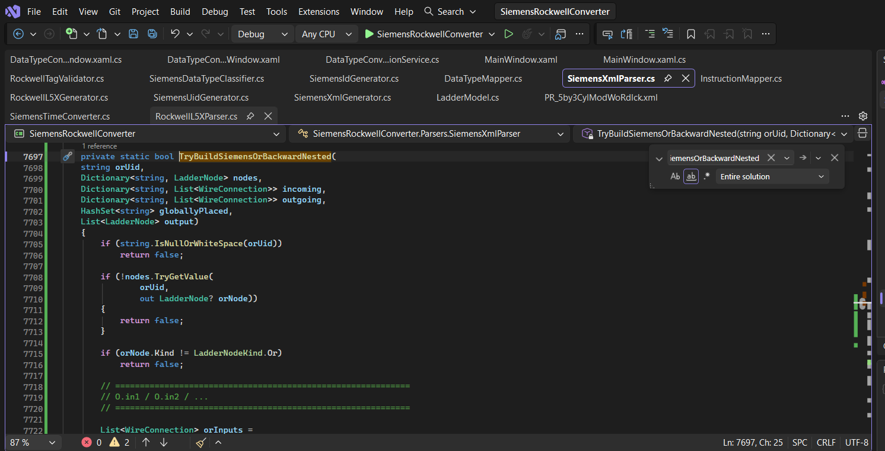

- ReadComment() Method Changed to add all comments correctly.
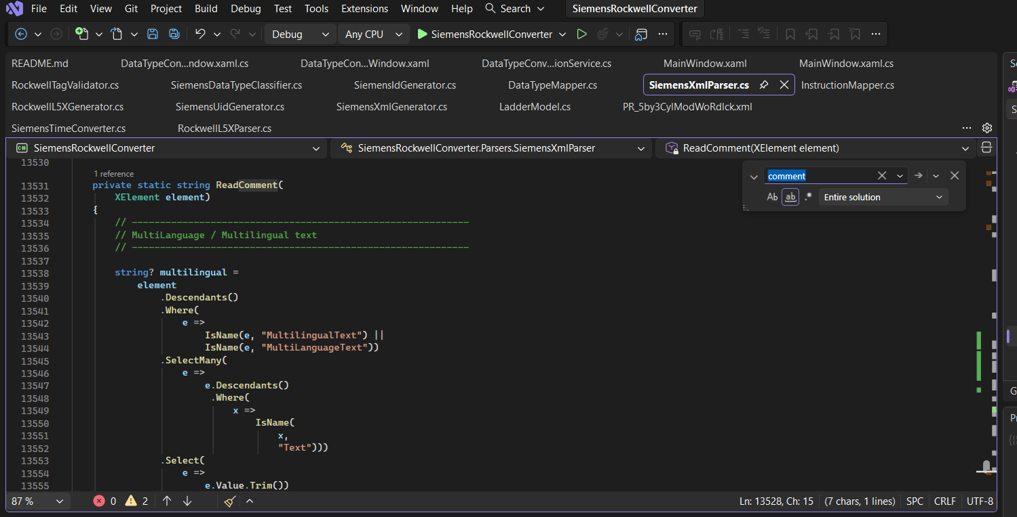
- All Timer Related Methods added(Timer conversion – PRE/ACC/Q/ET handling Done)
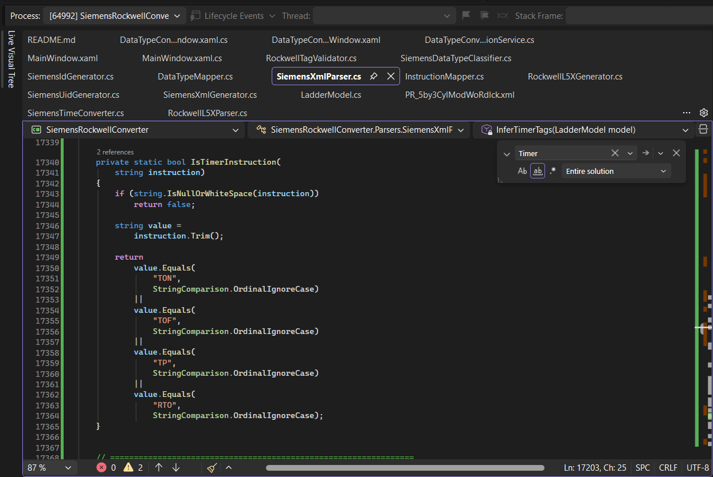

- Nested O / complex Siemens branch working on it.
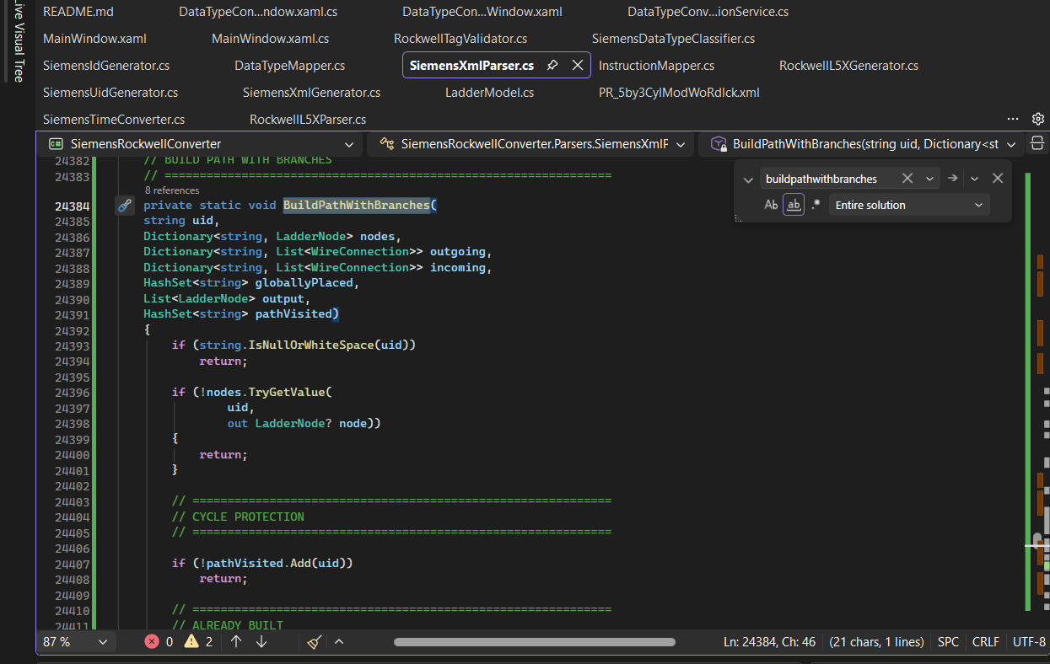
- converted all the applications that were previously console applications into Windows applications. This reduces the need for manual user interaction and makes the applications more user-friendly and easier to operate.
- Corrected the incorrect logic for INT arrays: When the datatype is an Array of INT, the corresponding Rockwell address is now generated using dot notation, such as QErr.1, instead of QErr[1].
Implemented Siemens UDT to Rockwell UDT conversion: Added the required logic to convert Siemens User-Defined Data Types (UDTs) into Rockwell UDTs.
Resolved the TIME conversion issue: Corrected the TIME conversion logic so that Siemens T#1S is now correctly converted to the corresponding Rockwell value of 1000 ms.

Using class HumanInLoopItem.cs display the pop up which contains the complex network like more than 3 or-ing, NOT block, true, false tags in network etc.
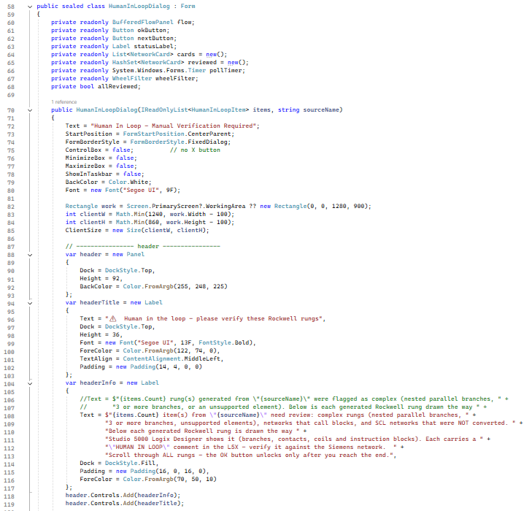
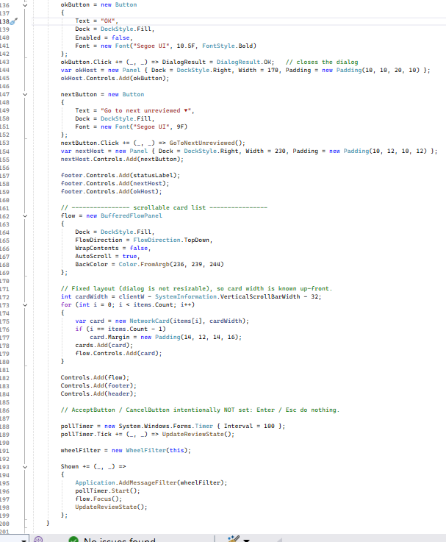

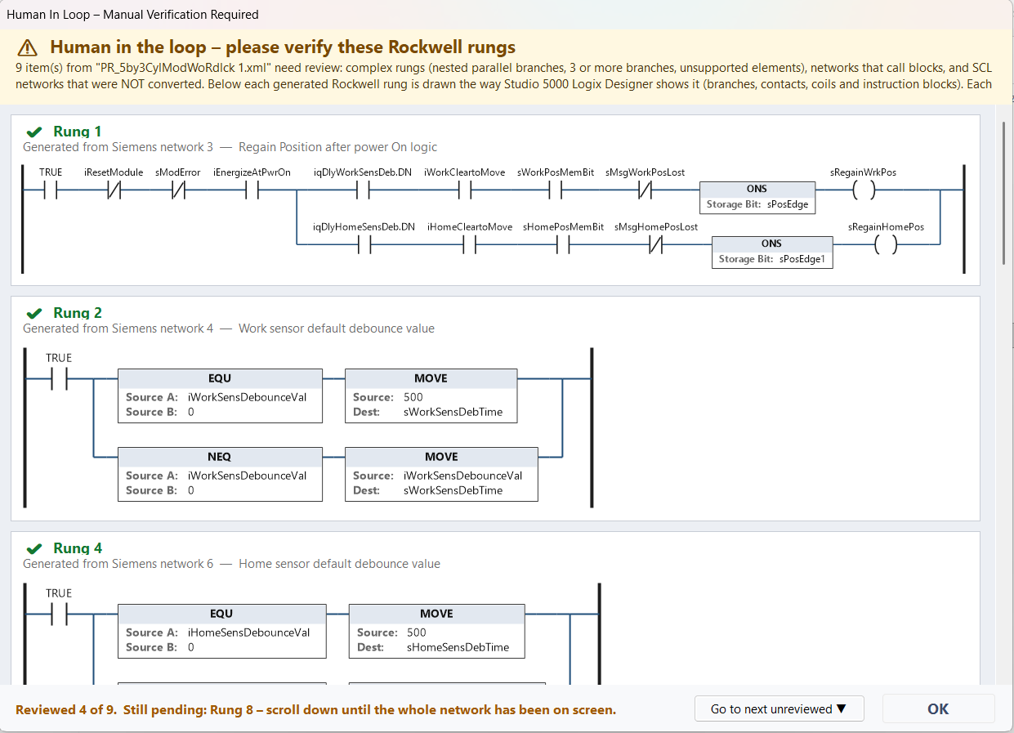

Conversion report
Every FB conversion writes Output\Report\<name>_ConversionReport.txt next to the L5X. It is produced by the static class ConversionReport.
Report section | Content
Declaration changes | Datatype mapped (Byte to SINT, UInt to INT and so on), timer / counter / string mapping, BOOL arrays packed, tags added as InOut with the reason, tags over 64 bits.
Network changes | For each network where a rule fired for constant TRUE/FALSE, NOT, block call, complex network: Siemens network number, Rockwell rung number, rung text and the applied changes (MID, LEN, Chars_TO_Strg, UDT COP, comparison with OR, constant TRUE/FALSE, NOT, block call, complex network).

Reset() is called from DeclarationMapper.Map; Declaration(rule, detail) records declaration changes; BeginNetwork(), Rule(rule, detail) and Constant(value) record changes while a network renders; EndNetwork(network, rung, title, rungText) stores the entry (rung -1 means no rung was generated); Write(path, warnings) writes the file.
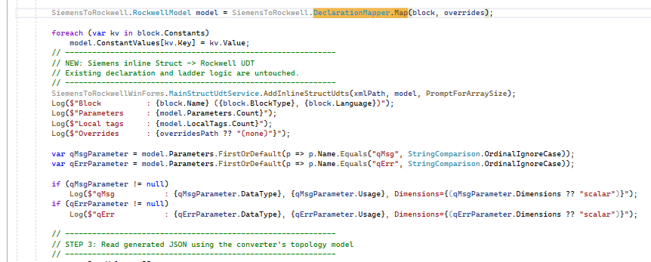
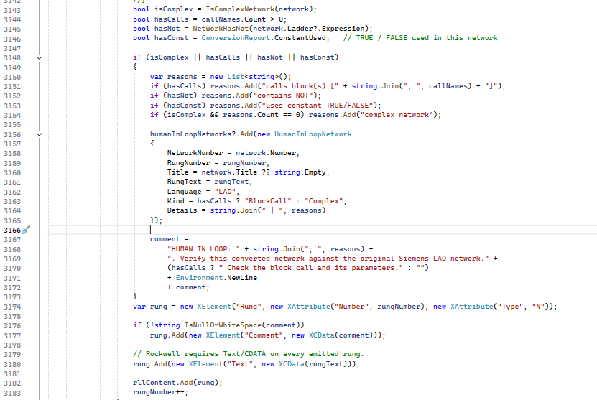
Using ConversionReport class generates the report.txt file and write the above method extracted data.

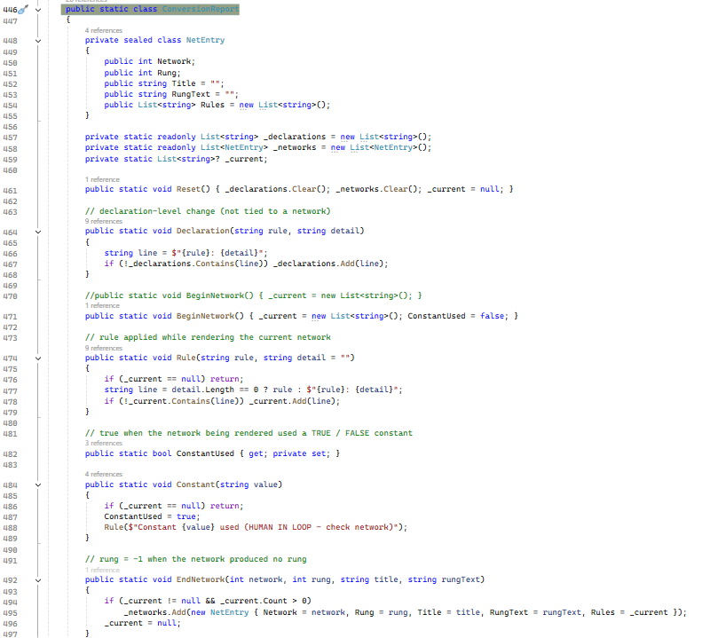
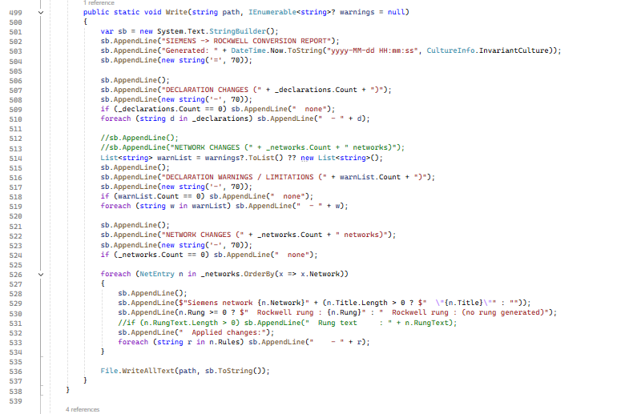
NetworkHasNot method is responsible for check the network contains NOT block if ye the return true.
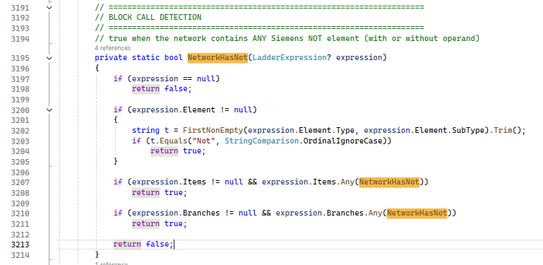
ConfigureBoolArrayPacking in this method update the logic check siemens output array tag if size is grater than 64 then declare in rockwell as it is in inout section
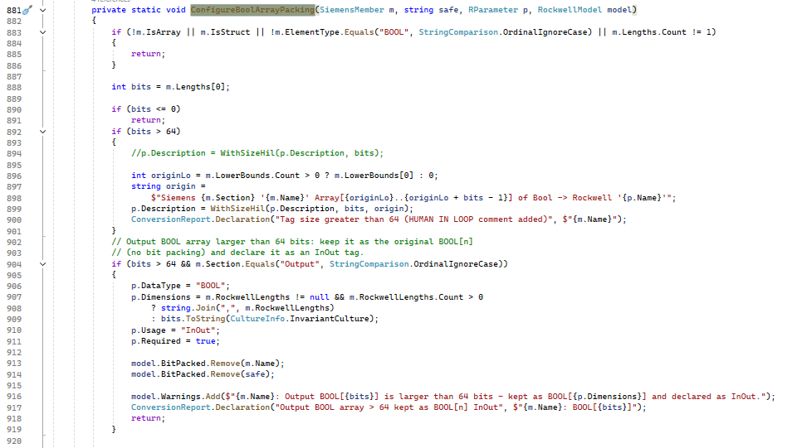
WithSizeHIL method write comment HIL if tag size is greater than 64
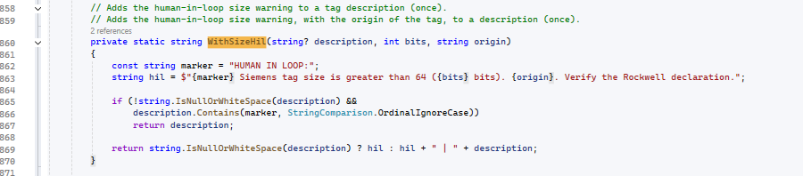
String Types
StringTypes.TryMap is the single rule used by DeclarationMapper. MapType, MapAtomicType (MainStructUdtService), MapType (UdtConversionService) and the safety net in CreateUdts.
A string is one value, not an array: a String_16 member has Dimension 0. The earlier rule that produced Dimension = string length was removed.
In UDT definitions the member radix for STRING, String_16, String_32, TIMER, COUNTER and UDT-typed members is NullType (GetUdtRadix).
String_16 and String_32 are custom Rockwell string types (Family StringFamily, members LEN as DINT and DATA as SINT array). They must exist in the Rockwell project before the generated L5X is imported. Import files were supplied for both.



